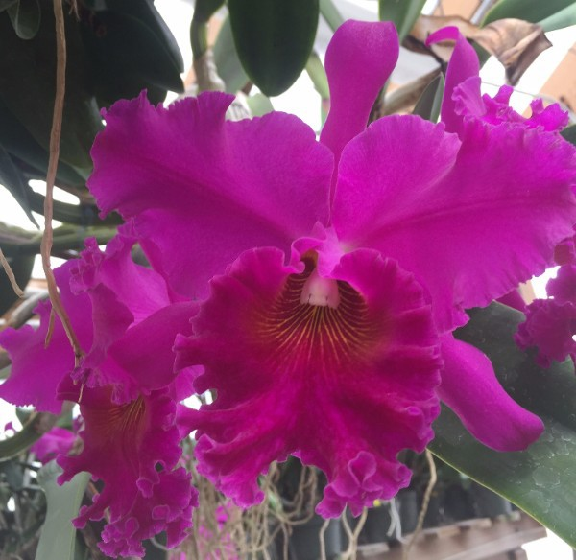
Subscribe
Share
Past Issues

December 2016 Newsletter View this email in your browser

New Mexico Orchid Guild Newsletter
December 2016

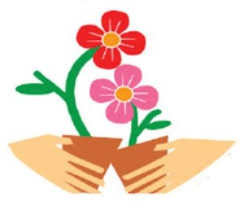

Our next regular meeting will be:

January 8th at 1:30pm

Albuquerque Garden Center, 10120 Lomas Blvd NE
(Just West of Eubank on the South Side of Lomas in Los Altos Park)

As usual, please bring something to share. Cakes, cookies, and other snacks are appreciated

Members are encouraged to wear their membership badges

Main Program: Orchid Exchange
Bring an orchid (or more) and exchange it for another.

Growers Forum:
Sphagnum Moss

What is it?
Why should I use it? How should I use it?

From the President’s Desk
Thanks to all who attended the November meeting to hear Francisco Miranda. Sorry for the small screen presentation. We have been assured that the large screen will be replaced before our January meeting.
At our January 8th meeting will be conducting our popular plant exchange. Bring an orchid (or more) and exchange it for another. Members bringing plants to exchange will draw a number to determine the order of selecting a new plant. The only rules will be: PLEASE no rescue plants or critters: i.e. mealybugs, scale, etc. Plant selection will continue in rotation until all donated plants have found new homes.
At last we have a 2017 show theme. Our theme will be Orchid Adventure and our resident artist extraordinaire (Marlene Roberts) is already working on our promotional poster. We are seeking a publicity chair to get the word out about the show and sale. If you are interested in helping to promote this annual event please contact any board member.
As 2016 draws to a close I am reflecting on the NMOG year. We have heard from some wonderful speakers including some of our very own members. Thanks Daniel, Jonah, and our June panel of veterans. We have learned and experienced hands on repotting.
We shared ice cream and conversation with others similarly affected with a passion for orchids. None of this “just happens”. I am blessed to be able to work with the most wonderful Board of Directors anyone could ask for. Thanks to Ana Benscoter for reliably tending to our library and Sean Houtman for transporting the library and snack supplies to each meeting. Special thanks to our departing board members: secretary Debby Lieberman for all her years of faithful service to NMOG and to Alyssa Christy Kolski for always being willing to help out no matter what the request. Welcome to new board members: Diana Williams and Judith Richey.
2017 will be another great year for NMOG. Jane Cole, vice president and program chair, is already planning our meetings. Ed is diligently watching our bank account and the members at large are busy planning the May show and sale.
NMOG operates on a calendar year so………………your dues are due. No change. Still $25 per household. Ed will accept your payment at the January meeting (you may charge it on your credit card) or mail it to the address on the membership form.
There is a membership form on the web site. Please do not pay your dues without completing a form even if there are no changes. This is the only way we have to keep your contact information current and we do not share this information with anyone outside our group.
Did you know that as a 501(c) 3 organization your donations to NMOG are tax deductible? As you plan your yearend charitable contributions, please consider donating to NMOG. Your support allows us to continue our mission of orchid education by providing quality monthly meetings including many internationally recognized speakers.
Hope to see many of you at the December 11th Holiday Party and the Happiest of Holiday Seasons to you all.
Keith

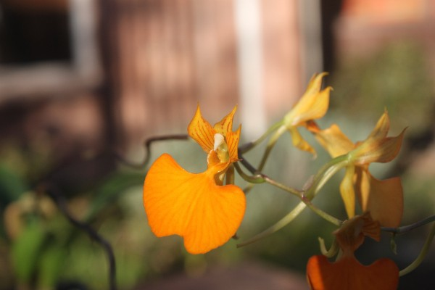

November Show and Tell Winners
Photos taken by Sean Houtman

Advanced Division--First Place Daniel Perry
Comparieta speciosa

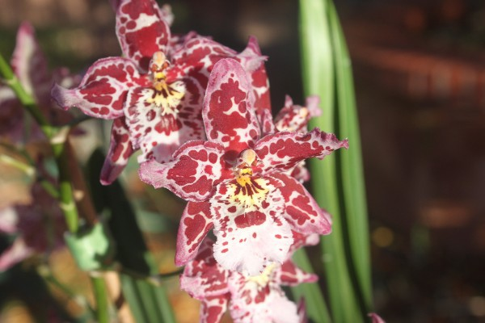
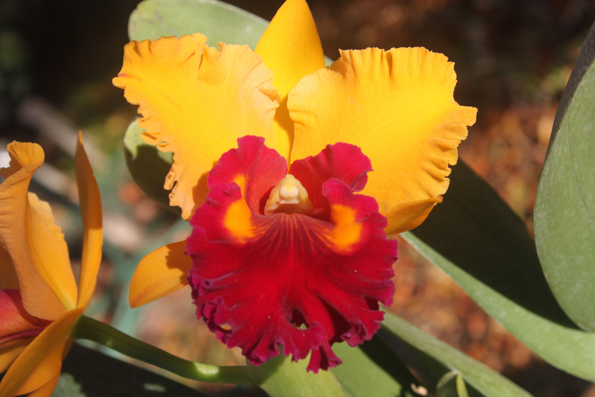

Advanced Division-- Second Place Judith Richey
Burrageara Austin Powers 'Sweet Summer'

Advanced Division - Third Place Susan Yamamoto
Blc. Toshie Aoki

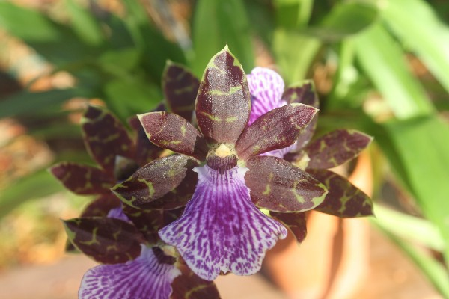
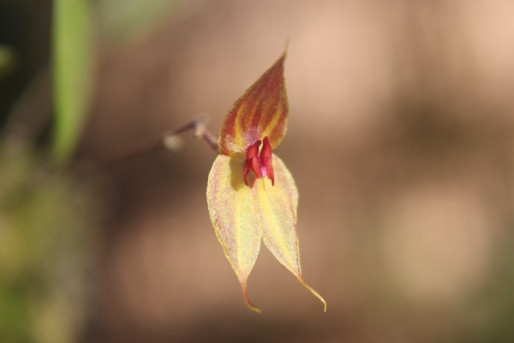

Intermediate division--First place Jonah Winn-Lenetsky Zygopetalum NOID

Intermediate division --Second Place Kelly McCracken
Lepanthes helgae

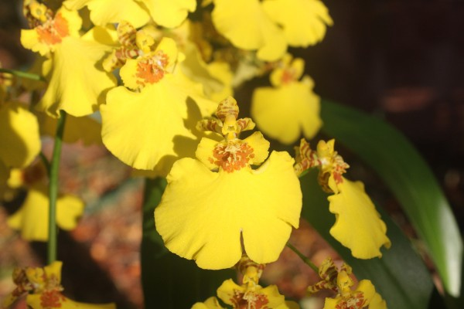

Novice Division -- First Place Edith Iwan
Oncidium sphacelatum

A Rather Humorous Discussion on Plant Hormones
(From: Shmoop.com/plant-biology/plant hormones)

Teenagers aren’t the only ones with raging hormones. Plants are full of hormones too, but luckily for them they don’t get pimples. In plants, hormones are responsible for all sorts of things, like helping the plants sense light, forming lateral roots, and triggering flower development and germination, just to name a few. If a plant had a Facebook account, it might write updates like “OMG my axillary branches are shooting up so fast” or “just tricked a bee into pseudo-copulating with my flower, lol.” However, plants don’t have Facebook, so they rely on hormones to be their messengers. Hormones are signaling molecules that are produced in small amounts and sent to other parts of the plant’s body, like tiny messengers running around.
Why should anyone care about plant hormones? Plant hormones are really important in creating the green world around us, and providing the fruits we eat and other plant products we enjoy on a daily basis. . Many things about plant hormones are still unknown, so it is a great field for a budding plant biologist (no
pun intended…well actually it was, sorry).
Here we will discuss five types of plant hormones:
- Auxin
- Cytokinins
- Gibberellins
- Abscisic Acid
Ethylene
Scientists were interested in how plants respond to light; if plants don’t have eyes, how do they sense where light is and which way they should grow? It is a common observation that plants grow toward light, but for a long time no one knew why. One of the first people to experiment with this concept was Charles Darwin, who along with his son, Francis, was interested in figuring out how plants respond to stimuli (in this case, light).
They noticed that coleoptiles, which are sheaths that protect grass stems as they germinate, bend toward light. They tried covering the coleoptile with foil and found that

when covered, the coleoptile didn’t bend. When uncovered, it bent again! From this the
Darwins concluded that the tip of the grass coleoptile senses light.
Even though it doesn’t seem very exciting now, in the 1800s this was just as scandalous as Lady Gaga’s meat dress. The idea that plants could do something as brilliant as respond to their environment was shocking in an age when Man was exerting control on all things, wild!
Later work by another scientist, Frits Went, determined that the signal responsible for bending toward light was a mobile chemical, and Went went ahead and gave it the name auxin.
These days, auxin is sometimes referred to by its chemical name, indoleacetic acid (IAA).

Auxin
Auxin does a couple different things in a plant, but its main role is to work with another type of hormone (cytokinins) to stimulate elongation of stems. If auxin is helping cells elongate, it is likely found in a place where a lot of new cells are forming. Where would that be? The shoot apical meristem, of course!
The shoot apical meristem is a major source of auxin, but not the only one. Developing seeds also produce auxin, which leads to fruit development. When fruits such as tomatoes are grown inside greenhouses where there are no insect pollinators, synthetic auxins are used to help fruits develop normally.
Another commercial use of auxin is in the vegetative propagation of plants from cuttings. Instead of planting seeds, people can grow some plants by just cutting a leaf or stem; spraying the detached leaf or stem with auxin induces root production, and a whole new plant is formed.

Cytokinins
Auxin helps cells elongate, but it doesn’t work alone. Auxin’s partner in crime is a class
of hormones called cytokinins.
Cytokinins promote cell division (cytokinesis) and are produced in roots, embryos and fruits, or wherever there is actively growing tissue. However, cytokinins need auxin to induce cell division. The ratio of cytokinins to auxin determines where cells will develop. If cytokinin levels increase, shoots form; if auxins increase, roots form. By themselves, cytokinins don’t cause any new tissues to form. Cytokinins do a couple other things too:
they help delay aging in plants by increasing the amount of new protein that is made and decreasing the amount of old protein that is demolished. Because of this, cytokinins are sprayed in flower shops to keep leaves green and cut flowers fresh.

Gibberellins
Gibberellins are most important in stems, fruits and seeds. In stems, they work with auxin to cause stem elongation.
Gibberellins and auxin also work in concert when fruit is developing. In fact, green seedless grapes are usually sprayed with gibberellins to make them bigger. Maybe that’s what Snooki (a Chilean-American reality television personality) sprays on her hair, too. Seeds have the problem of not knowing when conditions are right for germination; after all, they don’t come with calendars and thermometers. Lucky for the seeds though, they do have lots of gibberellins, which are released after seeds take up water (perhaps after a heavy spring rain). After gibberellins are released,
the outer layer of the endosperm releases digestive enzymes that break down nutrients in the endosperm. These nutrients feed the embryo as it germinates and grows into a seedling.

Abscisic Acid
It looks like a scary name, but abscisic comes from the word abscise, meaning to cut off or to fall away. On a plant, both leaves and fruits fall off, and abscisic acid (ABA), got its name because scientists originally thought that ABA caused leaves and fruits to fall off. It turned out later that other hormones (see ethylene, below) are mainly responsible for abscission, but the name stuck.
ABA does do some important things, even though it doesn’t do what it’s named for. ABA slows growth, and is the main player in seed dormancy. Since plants can’t exactly nurse their young and sing them lullabies like humans can, seeds have to be a bit more independent than a lot of animal babies. In fact, seeds are so
good at taking care of themselves, they don’t even start growing until conditions are right (temperatures are warm, or there is a lot of rain, or they get free tickets to Disneyland). The abscisic acid in a seed keeps it dormant (sleeping, basically). Certain

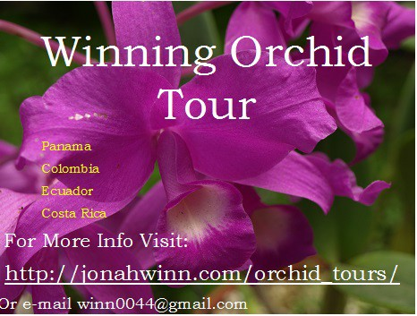

things, such as water, light, or even prolonged cold temperatures, cause the ABA to break down and cue germination of the seed.
ABA has another important role in plants: drought tolerance. When water gets scarce and leaves start wilting, ABA production is cranked up in the roots. ABA moves up the plant to the leaves.
As it accumulates in the leaves, ABA causes stomata to close, preventing more water loss. When water is plentiful again, the ABA breaks down and stomata reopen.

Ethylene
Where would we be without ethylene? We would have many unripe fruits, for starters. And without ripe fruits we would have no strawberry milkshakes, pineapple-mango smoothies, or Fruit Ninja. Ethylene helps fruits ripen by making them softer, through the breakdown components of the cell walls, and sweeter, through the conversion of starches to sugars. Unlike the other plant hormones, ethylene is actually a gas and is distributed through the air, not through the plant body. One of the coolest things about ethylene is that it is released in a positive feedback loop: a little bit of ethylene causes more to be released, which causes even more to be released, and so on.
A benefit of this fact is that you can take an unripe fruit (a pear, plum, or peach, for example) and put it in a paper bag with riper fruit (bananas work well for this) and ethylene will accumulate
making the unripe fruit soft and sweet.
Worldwide, billions of dollars of produce spoils every year before it is eaten. Thanks a lot, ethylene.

Classifieds
Email Kelly@dunnassoc.net to list orchids for sale or trade, orchid related items, or "In Search Of" posts

Facebook

Website

Copyright © 2016 New Mexico Orchid Guild, All rights reserved.

unsubscribe from this list update subscription preferences

