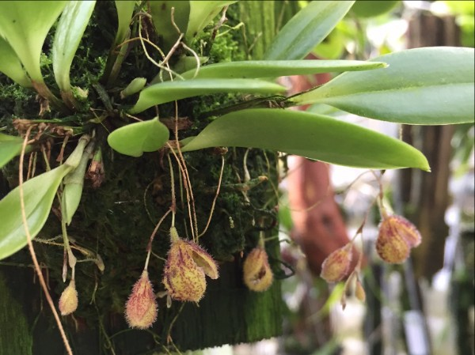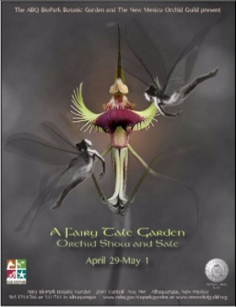

March 2016 Newsletter View this email in your browser

New Mexico Orchid Guild Newsletter

May 2016

Our next regular meeting will be:

June 12, 2016 at 1:30pm

Albuquerque Garden Center, 10120 Lomas Blvd NE
(Just West of Eubank on the South Side of Lomas in Los Altos Park)

As usual, please bring something to share. Cakes, cookies, and other snacks are appreciated

Members are encouraged to wear their membership badges

Cover photo is Pleurothallis
trichostoma photographed at Andy's Orchids

A Fairy Tale Garden Spring Orchid Show and Sale April 29, 30, and May 1st

Important dates to remember

PLANT CHECK-IN Wednesday April 27th 9am- 11am and 4pm-6 pm
RIBBON JUDGING Thursday April 28th 9am
PLANT PICK-UP Sunday May 1st 5pm SHOW HOURS 9am-5pm Friday-Sunday Members will receive a 15% discount throughout the show. Wear your 2016 NMOG badge for free entry into the Botanic Gardens

From the President's Desk:

May 2016
Our thanks to Jonah Winn-Lenetsky for sharing his photos of the orchids of Costa Rica and Panama at the April meeting. His presentation matched the orchids to the area and elevation in which they are found. It was educational and enjoyable.
As you read this our annual show and sale is about to happen. This is our major fundraiser and provides the funds for us to continue to bring you outstanding speakers
……..and plants!
This year the theme is A Fairy Tale Garden and the display will feature a fairy village and giant mushrooms. Not to be missed! The event will be at the ABQ Bio Park Botanic Garden showroom from April 29th through May 1st during park hours, 9 AM to 5 PM. Bring your friends and family and help support NMOG. Ribbon judging will be at 9 AM on Thursday, April 28th prior to completion of the display. For those entering plants, they may be picked up at the close of the show on Sunday afternoon at which time we will share sandwiches and announce the People’s Choice and Roger Easton award winners.
As a reminder, members in good standing (2016 dues paid and wearing their membership badge) are granted a 15% discount on orchids purchased at any time during the show. There will be an amazing variety of plants from which to choose. You will not find these at Trader Joe’s or the big box stores! In addition, all the props and non-orchid plants used in the display will be available to purchase and may be picked up at the close of the show on Sunday. See our Treasurer, Ed, for prices.
Due to a change in travel plans, our scheduled June speaker, Martin Motes, has asked to postpone his presentation to the fall. At the June 12th meeting a panel of our veteran members will discuss the major genera they successfully grow in Albuquerque and how they do it. This will be an interactive program with plenty of time for questions and sharing.
July 10th we will have an old fashioned ice cream social. No structured meeting. Just ice cream and socializing. Start searching for those great homemade ice cream recipes as we will all contribute and share.

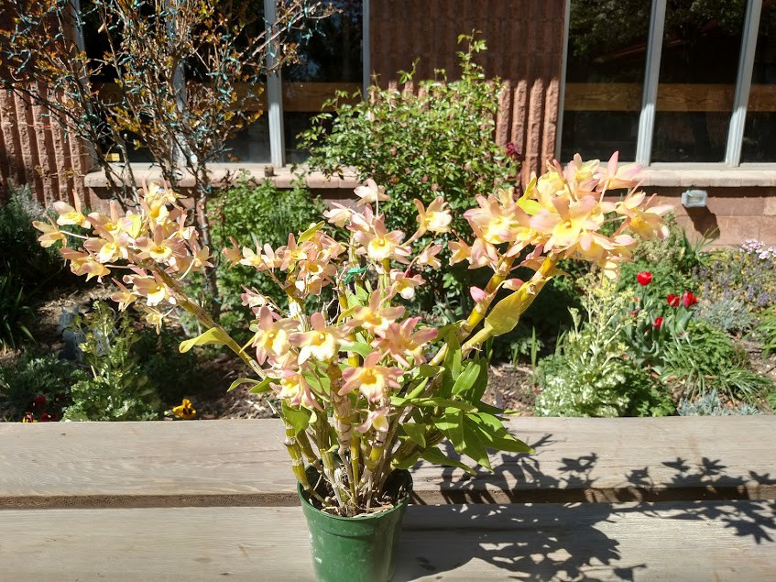See you at the show. Keith

NMOG Website: http://www.nmorchidguild.org/ American Orchid Society Website: http://aos.org

April Show and Tell Winners
Photos taken by Sean Houtman

Advanced Division--First Place Sean Houtman
Dendrobium Spring Bird 'Kurashiki'

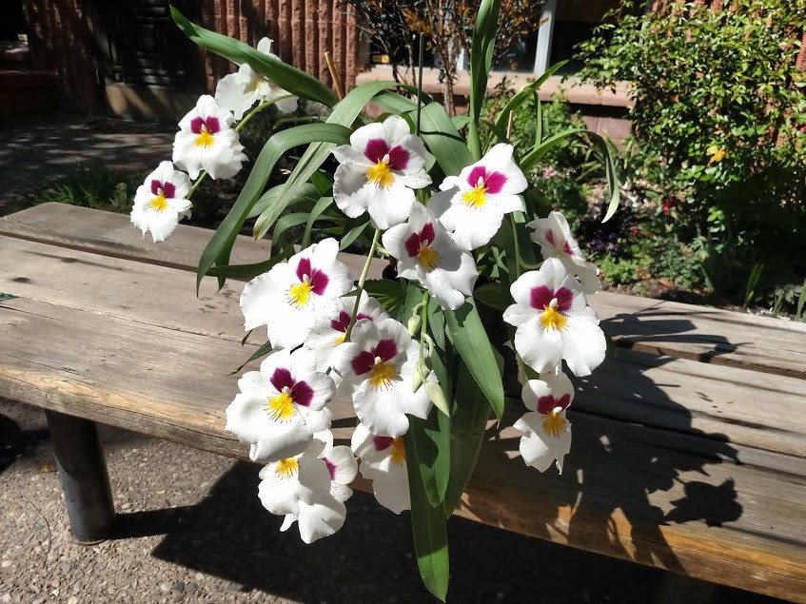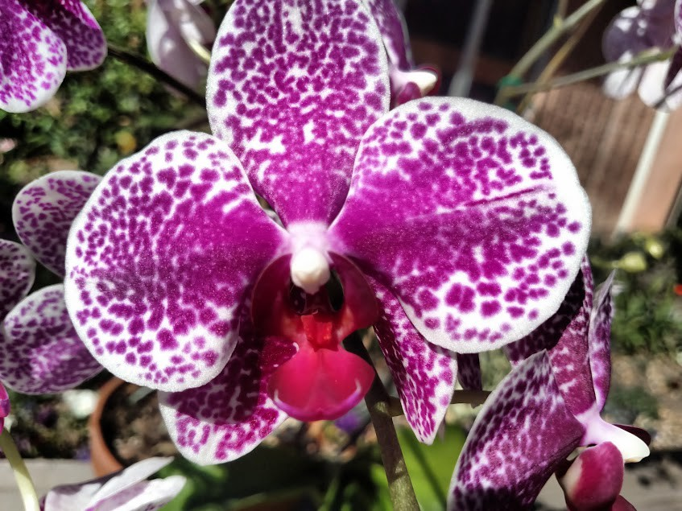

Advanced Division--Second Place Judith Rickey
NOID Miltonia

Advanced Division-- Third Place Robert Steinberg
Phalaenopsis NOID

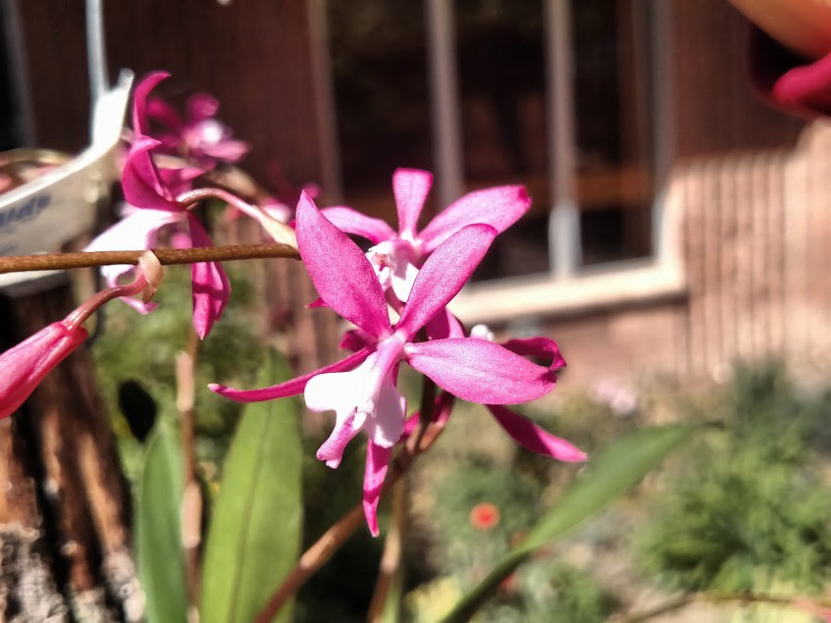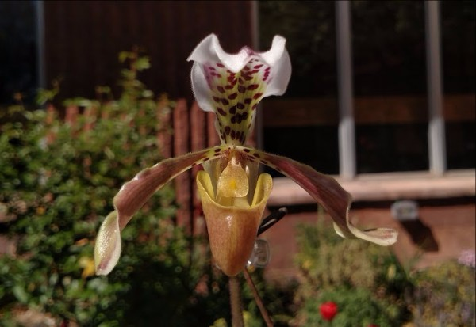

Intermediate division--First place Jonah Winn-Lenetsky
Cochlioda vulcanica

Intermediate division-- Second place Ed Hopper
Paphiopedilum gratrixianum

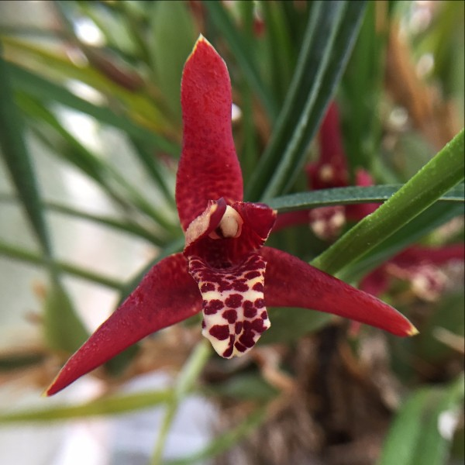

Novice Division First Place Diana Williams
Maxillaria tenuifolia

Retraction: This orchid was mistakenly titled as "Phal Sogo Yukidian" In April's newsletter. It is in fact Dendrobium Aussie's Chip, grown by Judy Richey.

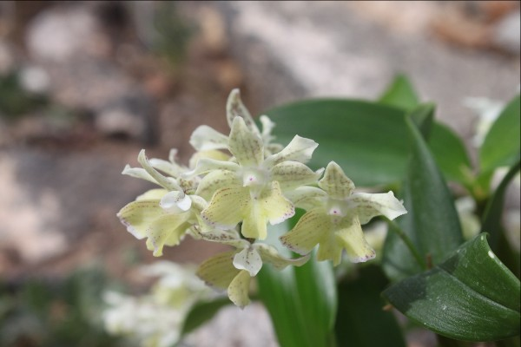A Visit to Sunset Valley Orchids and Andys Orchids

By Kelly McCracken

If you are interested in being interviewed for our newsletter, please call Kelly at 505-231-6816 or email kelly@dunnassoc.net

Sunset Valley Orchids in Vista, CA

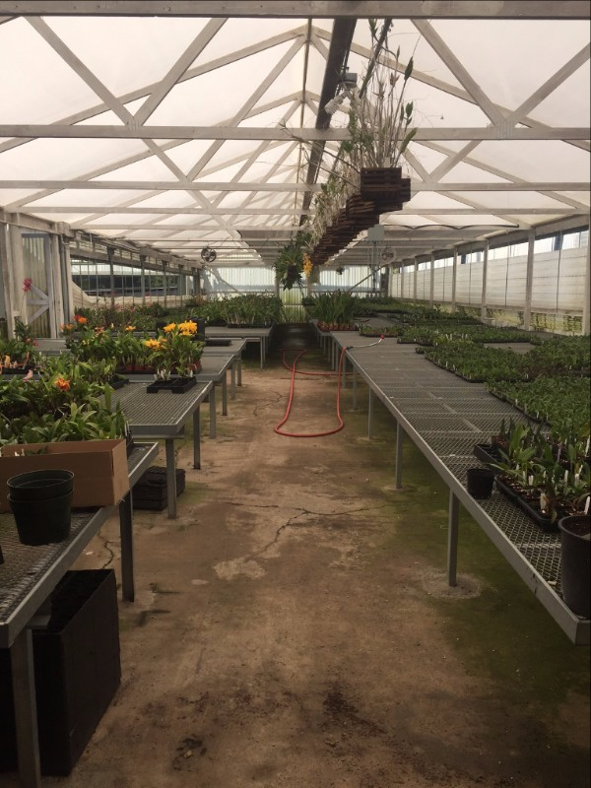I was lucky enough to visit Fred Clarke at Sunset Valley Orchids during a recent trip to San Diego.
This is one of Fred's greenhouses, the first one you see when walking into the building. Fred has nine acres in beautiful Vista, CA.

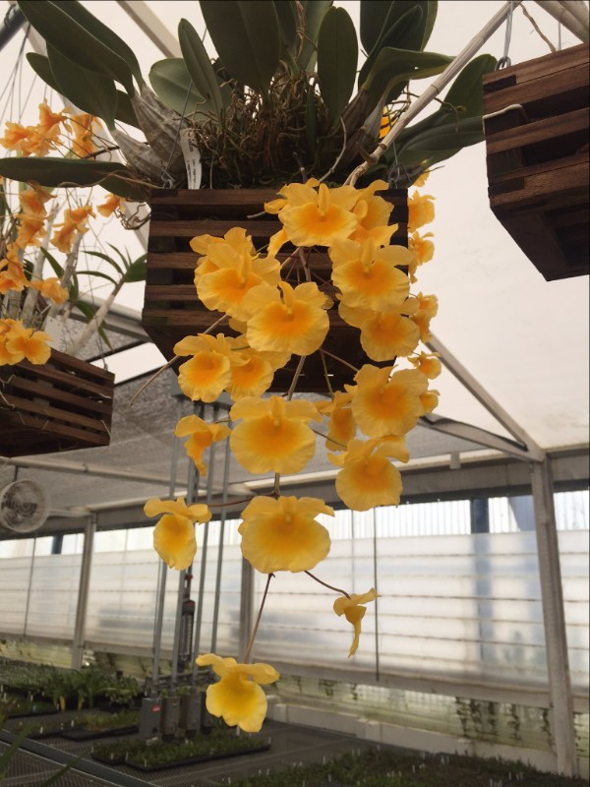Den. aggregatum

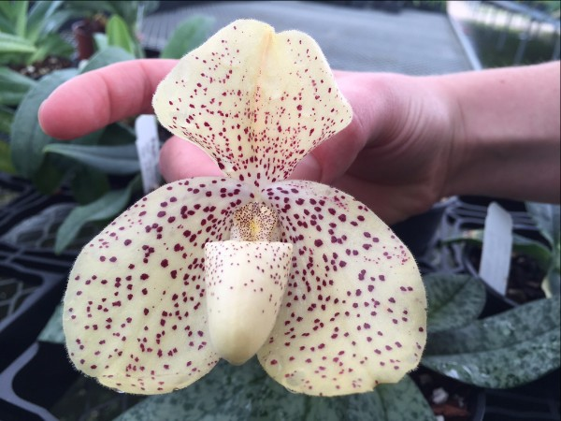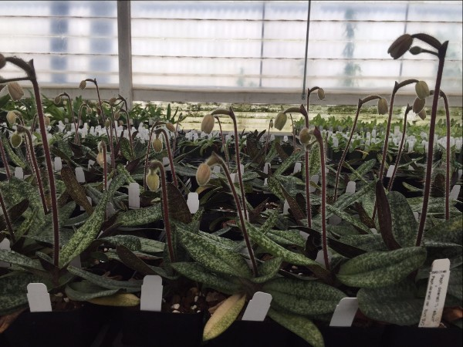

An enormous Paph. growing in the main greenhouse.

A plethora of Paph. delenatii plants in bud.

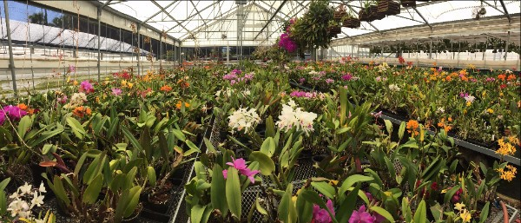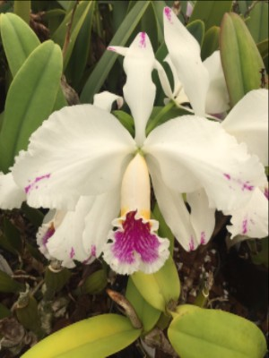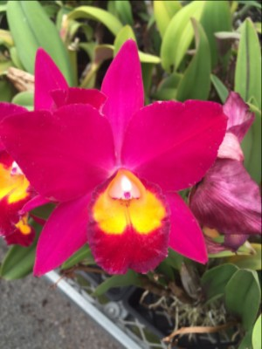A panoramic shot of Fred's "Breeding Stock" greenhouse.
Some of the worlds finest Cattleya's reside here, and absolutely everything was blooming!

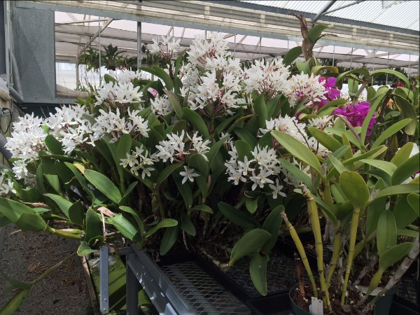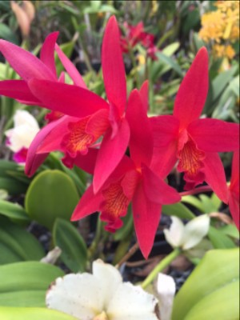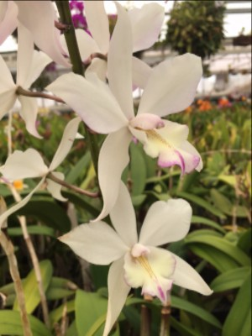This specimen was as big as a small car.

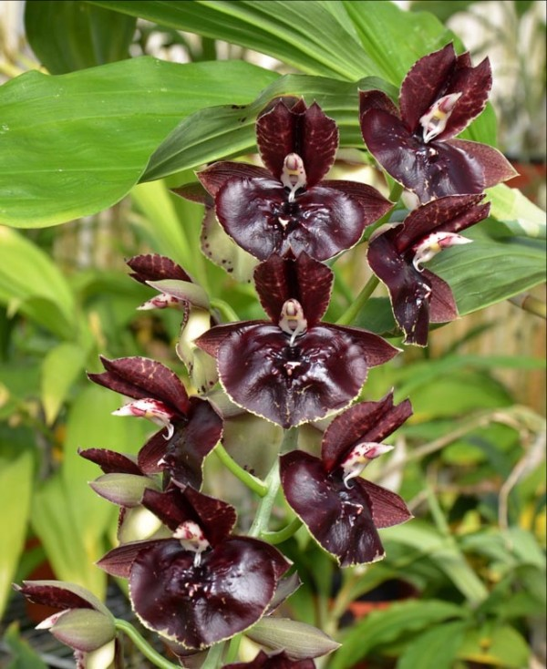Fred also grows Catasetum, Australian Dendrobiums and Paphiopedilums. Fred says Catasetum are the "hottest orchid" he sells right now, and has sold nearly a greenhouse worth of seedlings in just a few months! At the time of my visit, none of the Catasetum were in bloom. This is a picture of Ctsm. Louise Clarke 'SVO' from Fred's website.

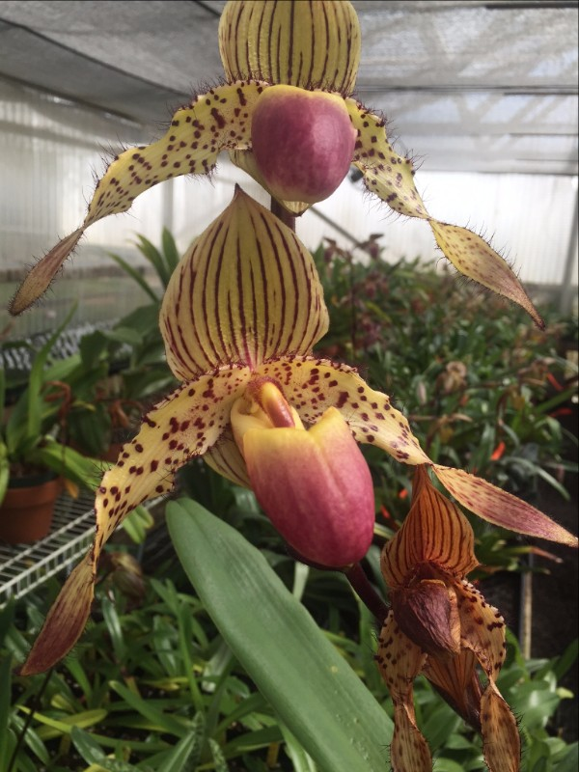A Paph in Fred's private collection

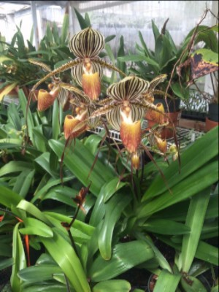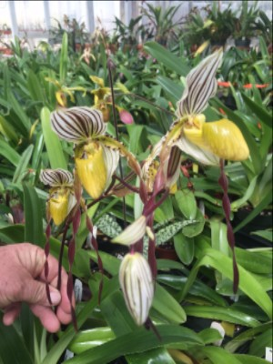
Andy's Orchids in Encinitas, CA

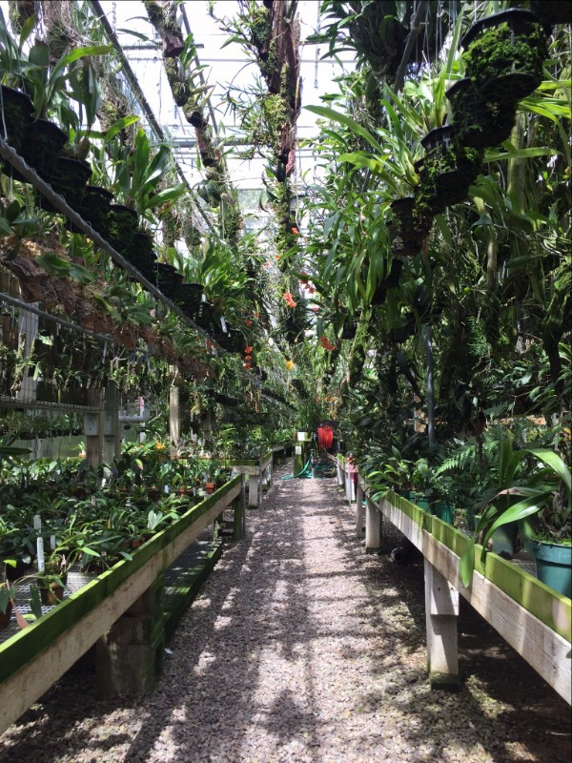Andy Phillips, owner of Andy's Orchids owns six acres of land in Encinitas, and houses over half a million orchids.
This is the "cool house". Here he grows Draculas, Masdevallias,Restrepia, Sarcochilus and lots of other cold-loving species. This greenhouse is basically open to the air, with no added humidity and very little heat.

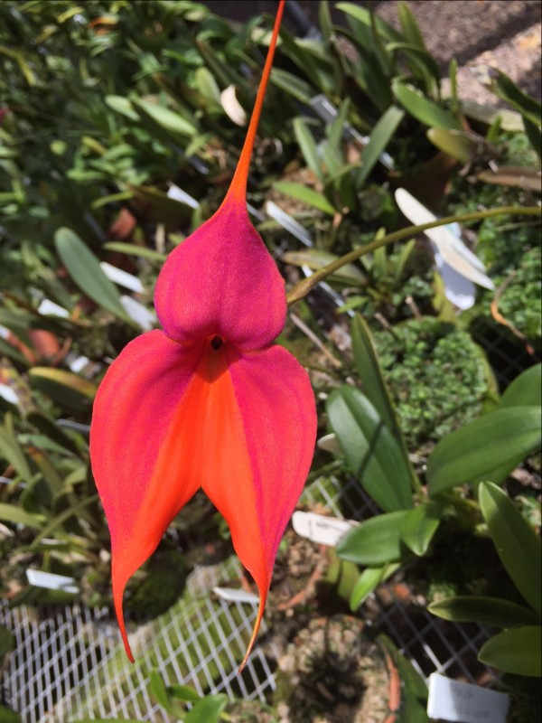A Masdevallia as long as my arm flowering in full sun in the Cool House

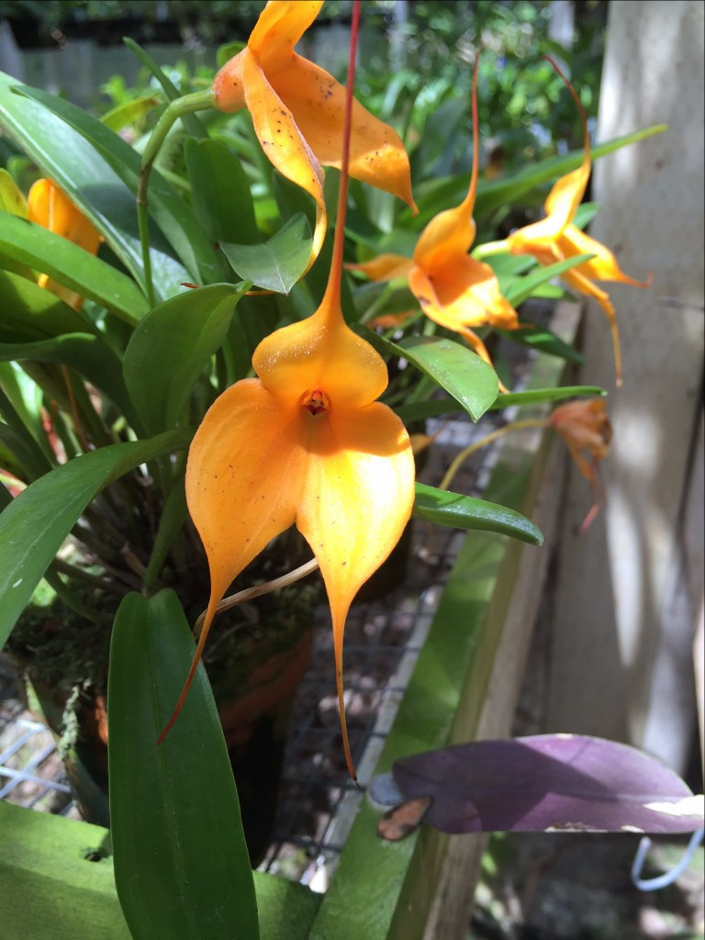Another (cuter) Masd. flowering in the cool house

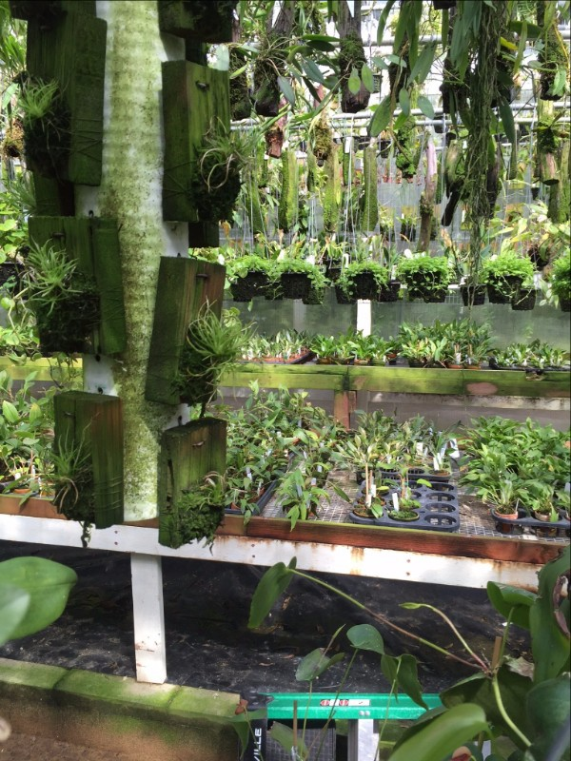There are layers and layers of plants at Andy's. Usually there is a waist-high bench with plants on it, then several horizontal bars that hold mounted orchids hang above the bench, perpendicular to the bench, there is a wall made of metal mesh that plank-mounted orchids hang from, and then more potted orchids hang above the mesh wall. There are also usually plants hanging above the walking aisles, forcing one to constantly evade roots and flowers. .

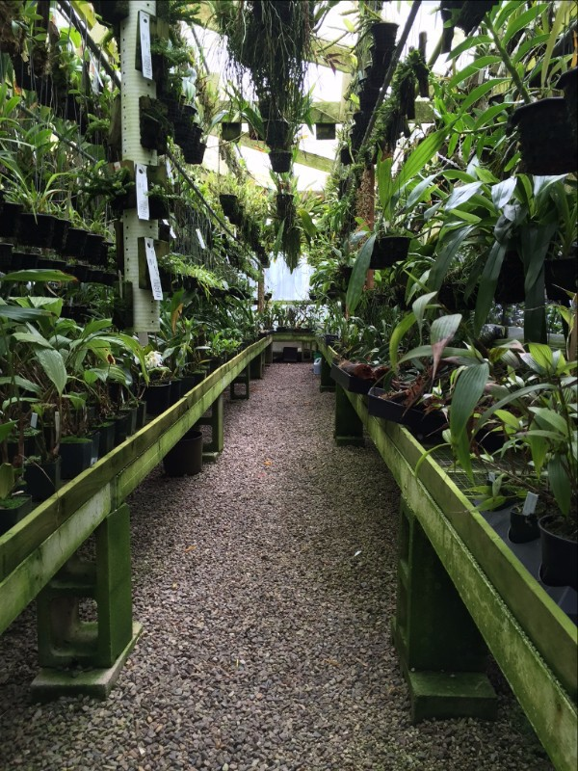Andy's has hundreds of species that are not listed on his website. If you're looking for a species but don't see it online, just call and they probably have it.

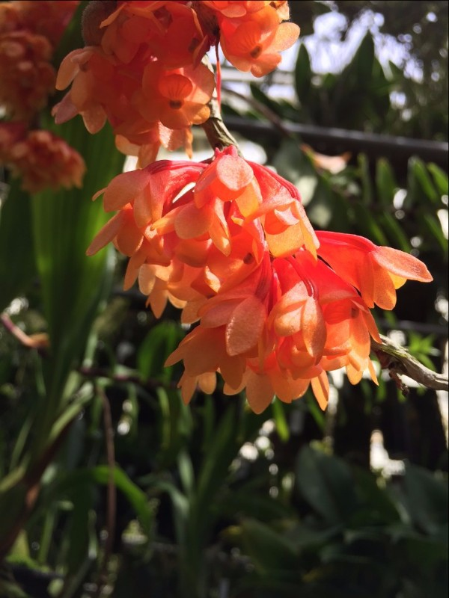Only some of the orchids in the greenhouse have tags. Andy seems to be able to identify any one of them by sight.

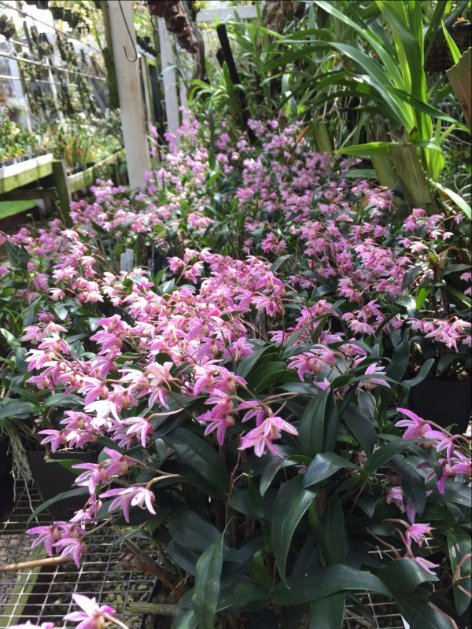A whole bench filled with Den. kingianum plants. These were growing outside in nearly full sun.

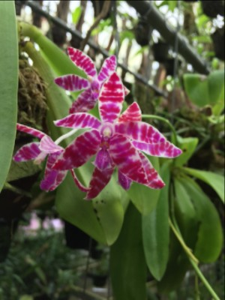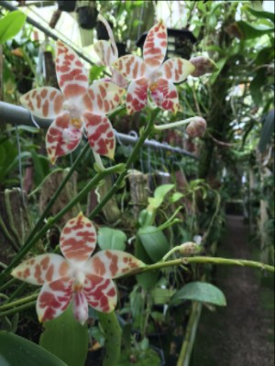
Phalaenopsis species flowering in the warm house.

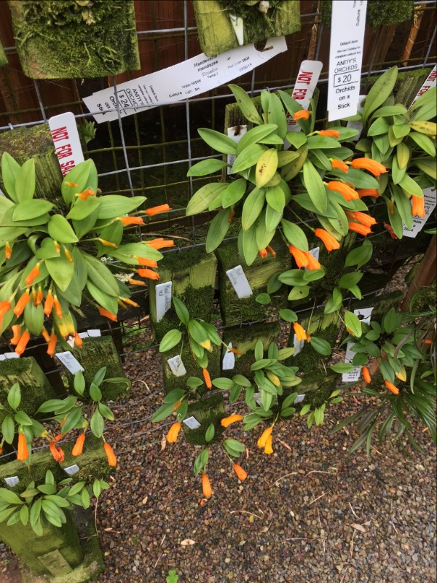A wall of warm-growing Masdevallias. Andy tends to keep the larger specimens and sell the smaller.

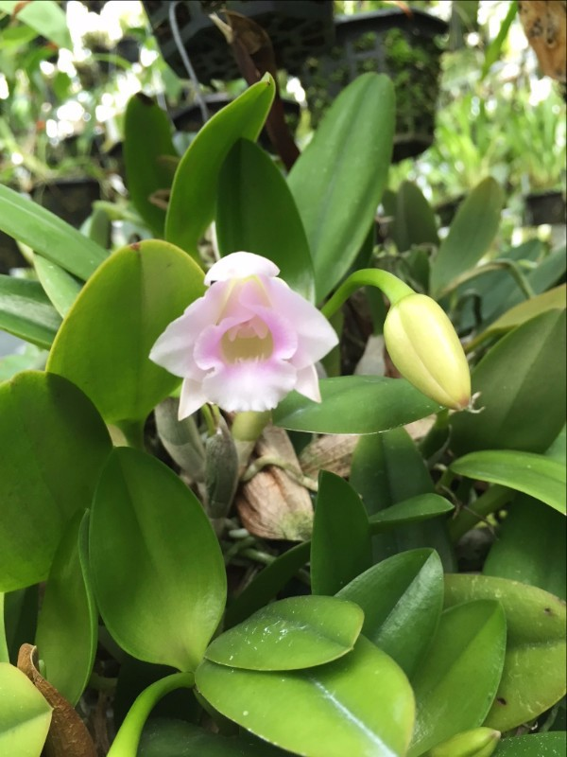

An enormous Laelia alaorii specimen. The whole plant was about the size of my torso.
Classifieds

Email Kelly@dunnassoc.net to list orchids for sale or trade, orchid related items, or "In Search Of" posts

Copyright © 2016 New Mexico Orchid Guild, All rights reserved.
You are receiving this email because you have expressed interest in the New Mexico Orchid Guild

Our mailing address is: New Mexico Orchid Guild PO Box 26473
Albuquerque, NM 87125

Add us to your address book
unsubscribe from this list update subscription preferences
Facebook

Website

